**Configure Azure CDN**

The Microsoft Azure Content Delivery Network (CDN) offers developers a global solution for delivering high-bandwidth content that is hosted in Azure or any other location. Using the CDN, you can cache publicly available objects loaded from Azure blob storage, a web application, virtual machine, application folder, or other HTTP/HTTPS location. The CDN cache can be held at strategic locations to provide maximum bandwidth for delivering content to users. The CDN is typically used for delivering static content such as images, style sheets, documents, files, client-side scripts, and HTML pages.

You can also use the CDN as a cache for serving dynamic content, such as a PDF report or graph based on specified inputs; if the same input values are provided by different users the result should be the same.

The major advantages of using the CDN are lower latency and faster delivery of content to users irrespective of their geographical location in relation to the datacenter where the application is hosted.

**Step 1:** Open Azure Portal.

**Step 2:** Click on **+New** -> Storage -> Storage Account

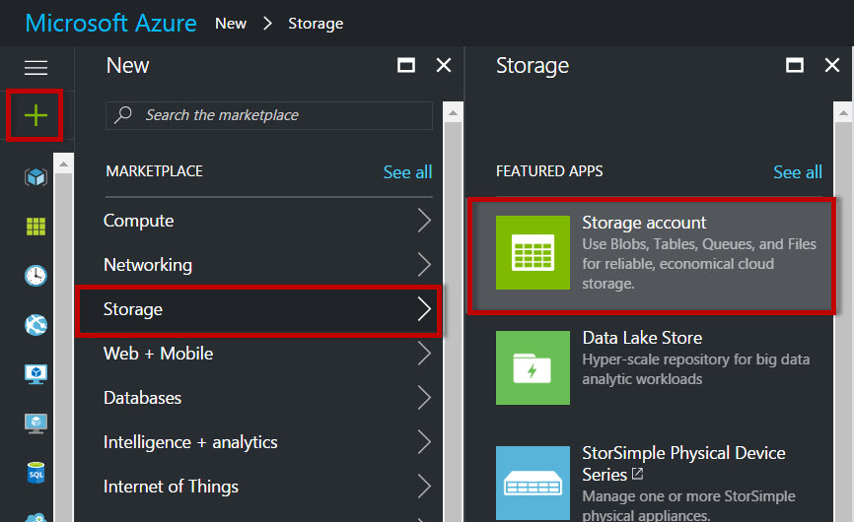

**Step 3:** Enter Storage Account Name, Performance, Replication, Location, etc.

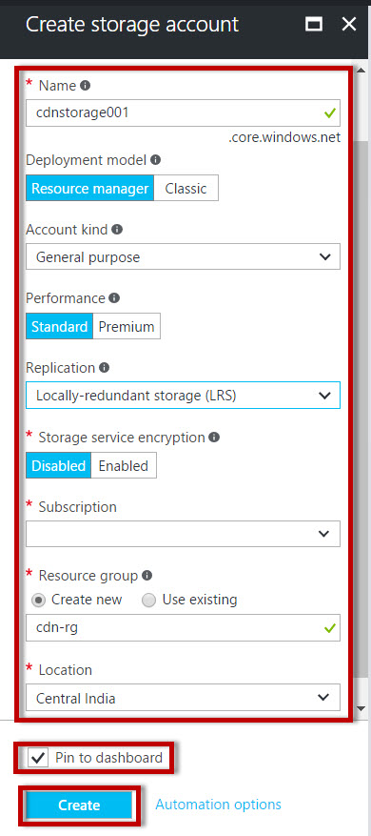

**Step 4:** Click on “**Blobs**”

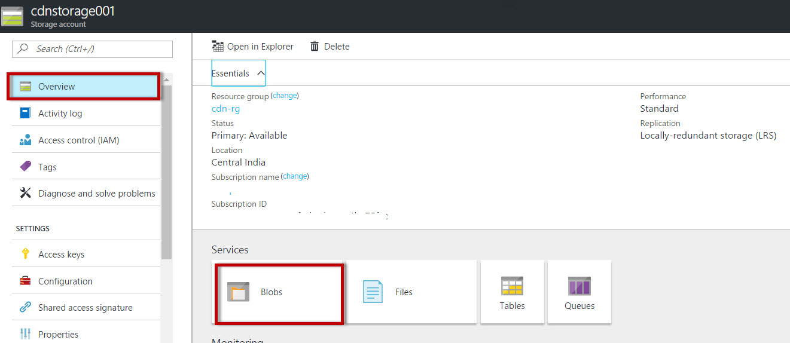

**Step 5:** Create New Container.

Container name: **publicfiles** & Access type: **Blob**

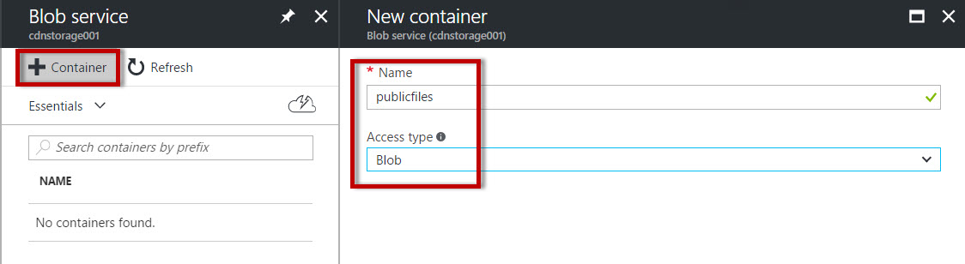

**Step 6:** Select Container name & Click on “Upload” option.

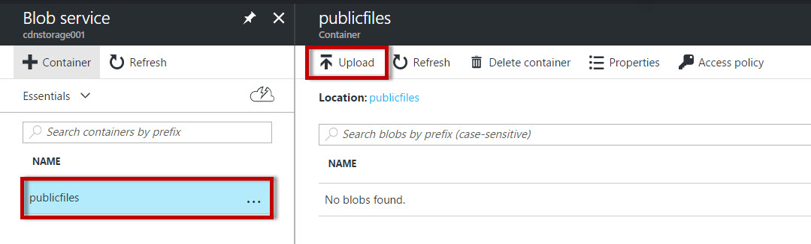

**Step 7:** Select any image file or any other file.

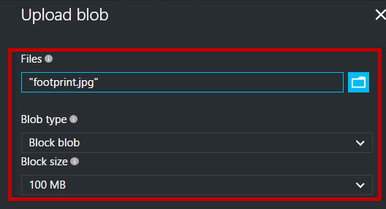

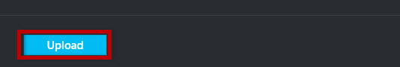

**Step 8:** Wait for few seconds to upload the content on the Container.

Select image file & copy the URL of image.

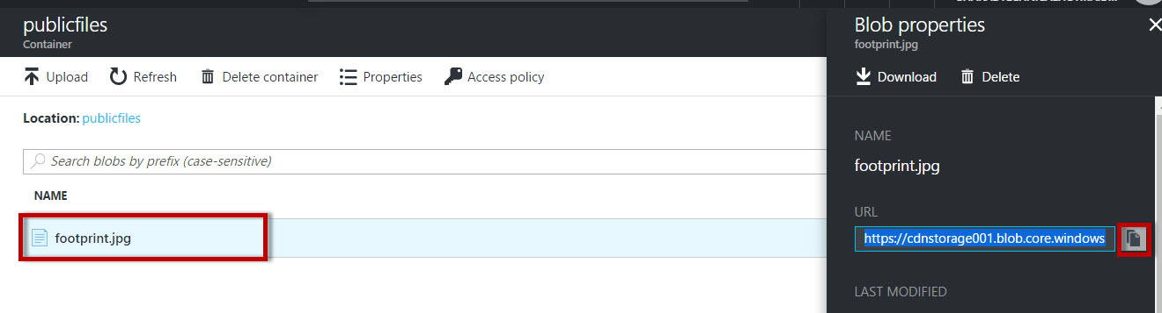

Open image URL in browser.

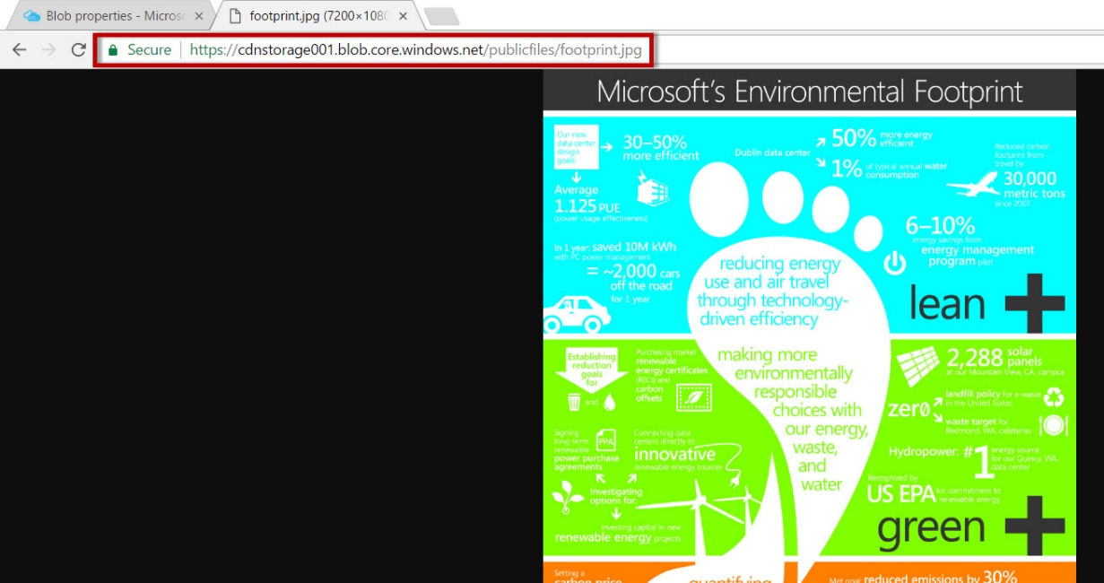

**Step 9:** Again click on **+New** -> Web + Mobile -> CDN

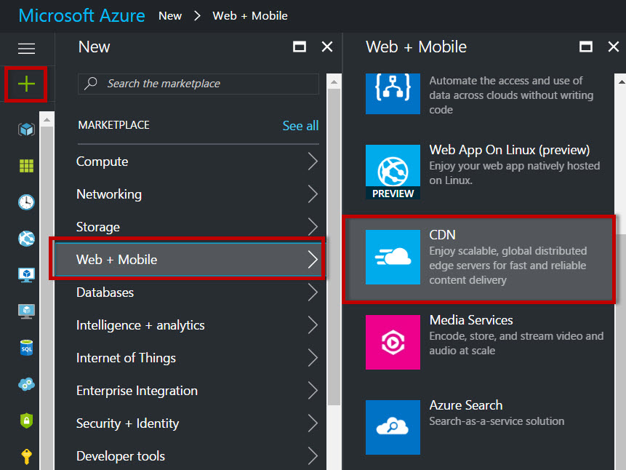

**Step 10**: Enter CDN Name, Choose existing resource group(storage account resource group), pricing tier: P1 Premium Verizon, S1 Standard Verizon, S2 Standard Akamai

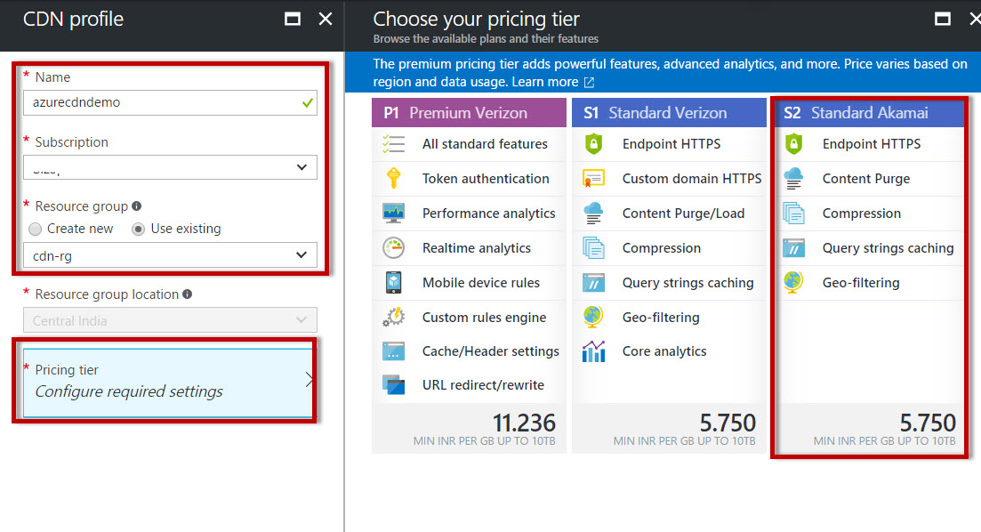

***Note****: Azure CDN from Akamai – Propagation will usually complete within one minute*

*Azure CDN from Verizon – Propagation will usually complete within 90 minutes or more.*

**Step 11:** Create New Endpoint

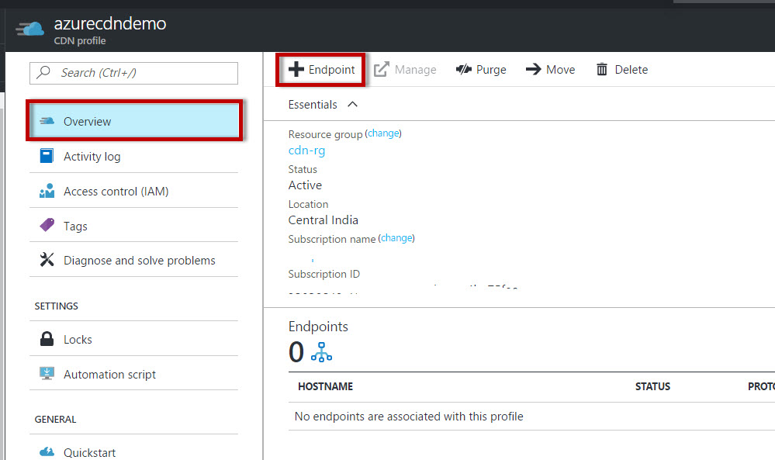

**Step 12**: Enter endpoint name,

Origin type: Storage,

Origin hostname: choose existing storage account

Origin path: /publicfiles (container name)

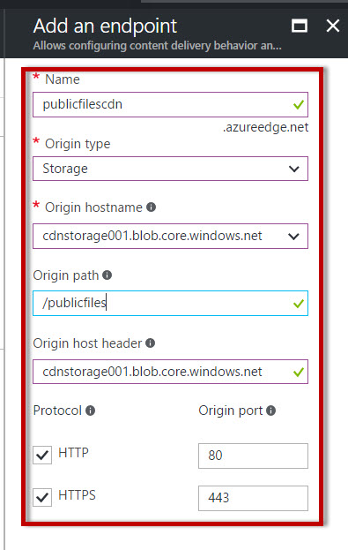

**Step 13:** wait for 1 minute to configure the CDN. When it’s done one endpoint will available.

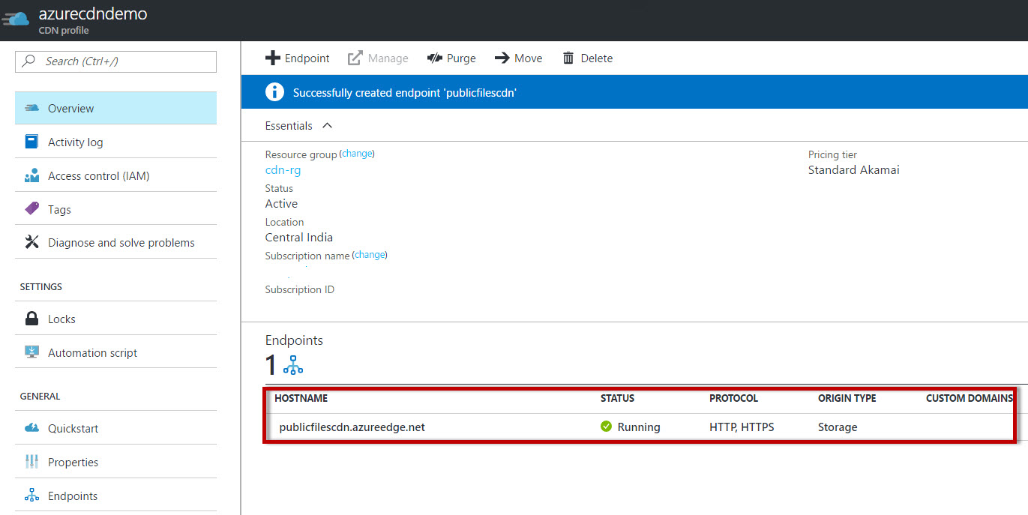

**Step 14:** Now again open browser & enter CDN URL with image file name.

Ex. https://cdnprofile.azureedge.net/image1.jpg

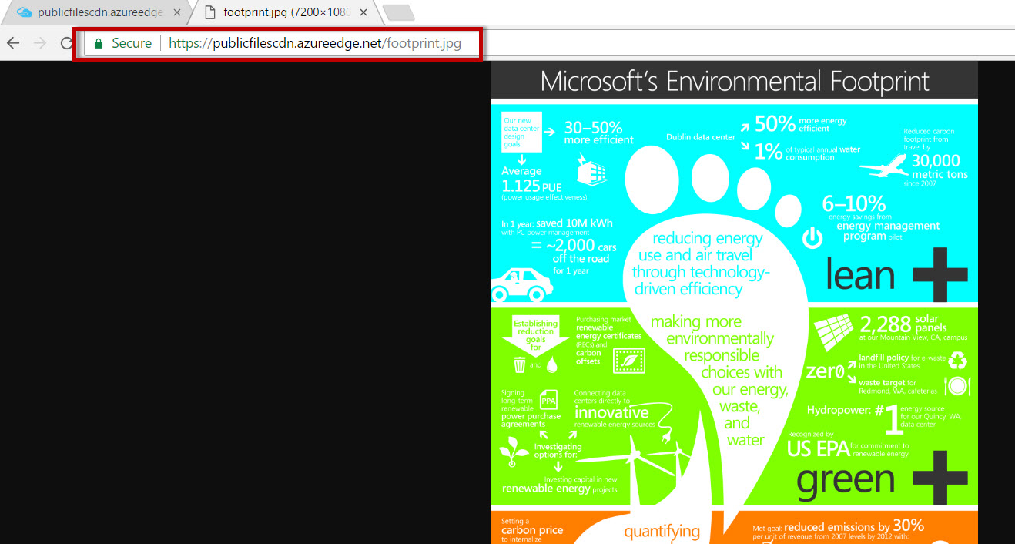

***Note****: for testing purpose, few websites are available*

<https://tools.keycdn.com/speed>

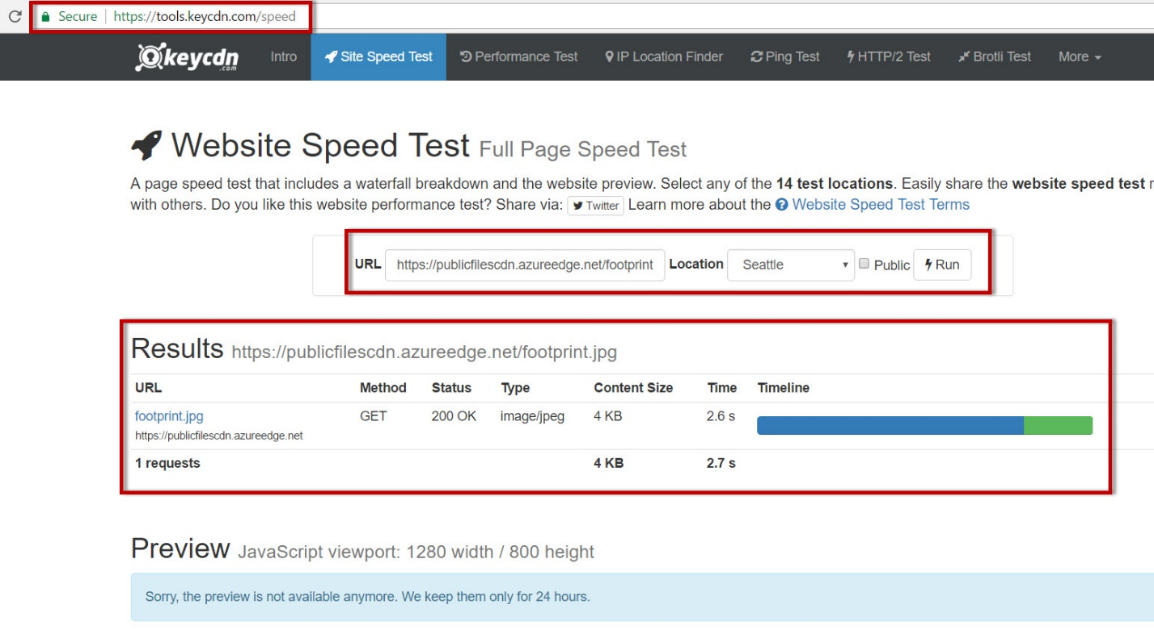

<https://www.webpagetest.org/>

